Midwest Philatelic Society 2015 Criteria for Exhibiting Awards
Midwest Philatelic Society
“First, Second, and Third Place Ribbon Awards”
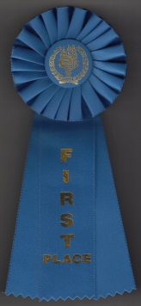 | 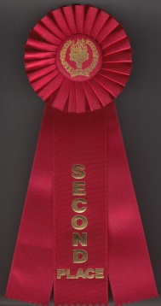 | 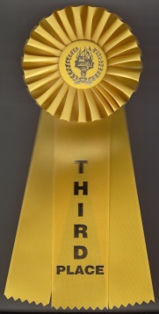
Criteria
Blue Ribbon = First Place, Grand Award
Red Ribbon = Second Place, Reserve Grand Award
Yellow Ribbon = Third Place, People’s Choice Award
Only club members who attend the MPS annual show may vote. Club members vote one time for First, Second, and Third place choices: only one ballot authorized per club member. Exhibit Frame Numbers are marked at the top right corner of each frame. Special ballots and a show brochure provided at the show.

Midwest Philatelic Society
“Junior Exhibitor First Place Award”
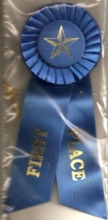 | Criteria  This ribbon shall be awarded to the exhibit entered by a junior exhibitor that best follows the exhibiting practices presented by APS/AAPE guidelines. To qualify for this award the following provisions must be met:
- The exhibit shall have a title page plus a minimum of four pages containing philatelic material.
- There must be at least two junior exhibitors presenting such exhibits between the ages of 10 and 16.

Midwest Philatelic Society
“The Martin Finklestein MPS Research Award”
Criteria
The award will be given to an exhibit which:
- Displays the best original research,
- secondary research,
- assemblage of information from several sources usually arriving at a conclusion never before published,
- in-depth study for which little or no philatelic documentation has been recorded,
- or in-depth study with an original approach which covers areas not seen on the subject.
Note: Conventional data gathered from stamp catalogs is not considered original research information.

Women Exhibitors
“Sterling Achievement Award”
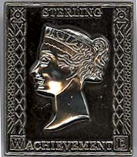
Criteria
- To recognize ANY exhibit that did not win one of the club’s 1st, 2nd, or 3rd place ribbons, but shows merit in philatelic knowledge, subject knowledge, material OR treatment.
- Serves as an encouragement to a promising exhibit.
- The award is not only for women exhibitors: it can be given to ANY exhibit, including those by men and youth, who meet the criteria.

The American Association of Philatelic Exhibitors
“AAPE Silver Award of Honor Pin”
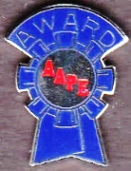
Criteria
- AAPE requests the pin be awarded to the exhibit that did not win the club’s 1st place ribbon, but best exemplifies the high standards of philatelic exhibit presentation per the following criteria:
- Exhibit Layout: The balanced and eye appealing arrangement of exhibit pages; highlighting of an exhibit’s material.
- Title Page: Does it aid the viewer in following the exhibit’s logical progression? Is it written in concise, yet descriptive terms that act as a “road map” for the viewer of the exhibit?
- Logic of Progression: How logical is the sequence of the pages in telling the material’s story? Is the material pertinent to and within the parameters set down by the title? Does the exhibit have a beginning, middle and end?
- Write-up: Is it pertinent, brief and non-redundant?
- Neatness: Are the pages clean? Is the write-up method neat and tidy? Are mounts subtle and even?

United States Stamp Society
“President’s Award”
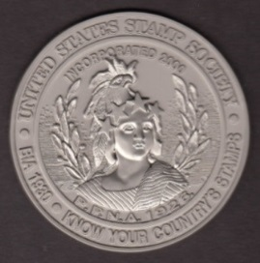
Criteria
- The award should go the best U.S. exhibit of postage stamps, revenue stamps and/or stamped paper of the United States and its administered areas as further defined in this criteria. The exhibit must win one of the club’s 1st, 2nd, or 3rd place ribbons.
- Eligible Exhibits:
- Exhibits of the following types of material of the U.S. administered areas or possessions:
1) Postage and Special Postal Service Stamps, 2) Revenue Stamps, 3) Postal Stationery, 4) Local and Carrier Stamps, 5) Revenue Stamped Paper, 6) Test Stamps, 7) Dummy Coils, etc.
- Exhibits of the following classes, divisions or types when a U.S. area is the focus:
1) Traditional, 2) Postal Stationery, 3) Astrophilately, 4) Revenue, 5) Marcophily, 6) Postal History, 7) Aerophilately, 8) Special Studies, 9) Display Class, 10) First Day Covers, 11) Illustrated mail exhibits that include a focus on the postal emissions such as the postage stamps, stationery, etc.
- Exhibits not Eligible:
- Following are exhibit categories and subjects not eligible for this award:
1) Exhibits of Stampless Material because the USSS has a primary focus on the study of adhesives, 2) Cinderella Material where specifically seals, labels, trading stamps, propaganda, etiquettes and similar material., 3) Illustrated Mail Exhibits where there is no focus on the postal emissions such as the postage stamps, stationery, etc., 4) Confederate Material.

Special Information
- Judges who determine supplementary awards are appointed by the Exhibits Chairman. Minimum requirements include their medal level standing at the World Series of Philately exhibiting competitions; Vermeil Medal or above.
- Award recipients must provide their exhibits to the Exhibits Chairman for scanning. The electronic file will result in a PDF format and placed as a link on the MPS website for viewing by club members, visitors to our site, and agents who donated awards from external organizations.
- Awards are given only when warranted. If no exhibit displays a sufficient level of achievement of any supplemental award, the award will be withheld.
- Consideration for awarding 1st, 2nd, and 3rd place ribbons will depend on the total number of exhibits. If 10 to 12 exhibitors participate, a 1st, 2nd, and 3rd place ribbon will be awarded. If 7 to 9 exhibitors participate, a 1st and 2nd place ribbon will be awarded, and if 2 to 6 exhibitors participate, only the 1st place ribbon will be awarded.
- All exhibitors receive the MPS Annual Lapel Pin and a Certificate of participation.

